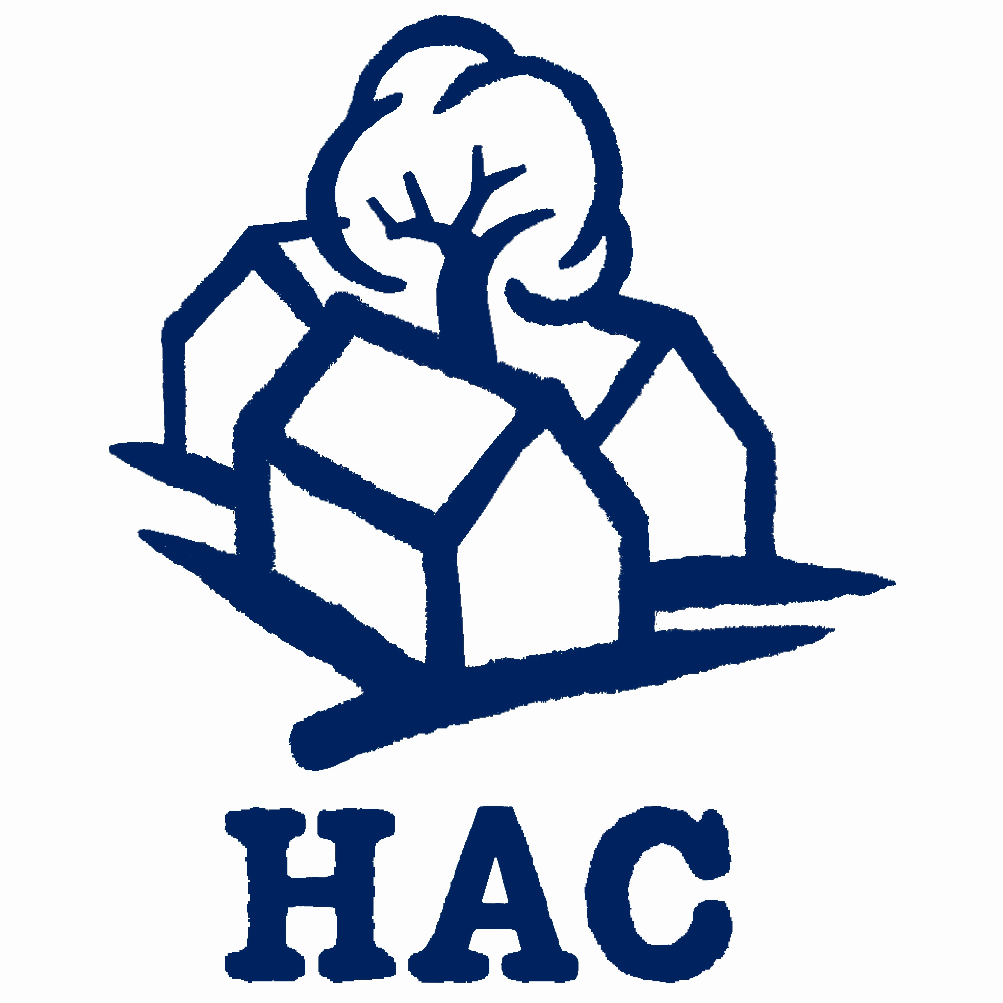
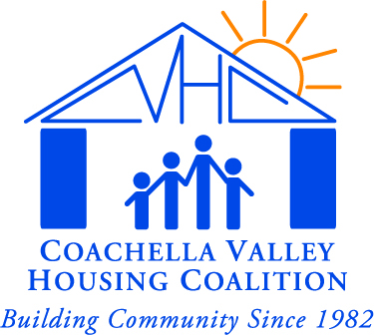

M E D I A A D V I S O R Y

Contacts: Janice Clark, Housing Assistance Council, (443) 286-1538 cell
John Mealey, Coachella Valley Housing Coalition, (760) 347-3157

NATIONAL HOUSING LEADERS TO TOUR LOCAL SITES
Housing Assistance Council Board Will View Affordable Homes

What/Where: At the invitation of the Coachella Valley Housing Coalition, the board of directors of a national rural housing organization will tour affordable housing in La Quinta, Indio, Coachella, and Mecca, California on Friday, May 21. The Housing Assistance Council’s board will visit self-help housing subdivisions, farmworker and migrant housing, and rental housing. HAC will also visit the Torres Martinez Indian Reservation and the desert mobile home park known as Duroville.

Who: Residents will be available for photographs and interviews in both Indio and Mecca. Representatives of national and local housing organizations will be available on the bus, at the sites, and at lunch. These include the Housing Assistance Council and its local host Coachella Valley Housing Coalition. Most of these speakers are bilingual in English and Spanish.

When: Friday, May 21, 2010.
Media representatives are welcome to join the group at any or all of the scheduled stops. A complete agenda is attached. Highlights are:

Indio
8:50 a.m., Desert Gardens Apartments (83-880 Avenue 48)
Mecca
12:30 p.m., Paseo do los Heroes I, (62-900 Lincoln Street). Followed by Video presentation and lunch. Please RSVP if you will be joining the group for lunch.
2:00 p.m., Huerta de Mecca Self-Help Subdivision (Southwest corner of Johnson Street and Avenue 65)
La Quinta
5:30 p.m., Reception at the Embassy Suites Resort (50-777 Santa Rosa Plaza). Please RSVP if you will be joining the group for the reception.

A national nonprofit corporation headquartered in Washington, D.C., and founded in 1971, the Housing Assistance Council helps local organizations build affordable homes in rural America by providing below-market financing, technical assistance, research, training, and information services. HAC’s programs focus on local solutions, empowerment of the poor, reduced dependency, and self-help strategies.

####

Housing Assistance Council and Coachella Valley Housing Coalition

Tour Itinerary

8:00 am  La Quinta | Tour Begins at Embassy Suites Hotel
8:30 am  La Quinta & Indio | Drive by and view: Wolff Waters Place – Family Housing; La Hacienda Apartments - Elderly and Mentally Disabled Housing
8:50 am  Indio | Walking Tour: Desert Gardens Apartments - Family and Retired Farmworker Housing
10:00 am  Coachella | View: Paseo do las Palmas, Rancho Cielo, and Los Jardines Self Help Subdivisions
12:00 noon  Mecca | Walking Tour: Paseo de los Heroes I Mobile Home Park – Family Housing; followed by lunch and video presentation
2:00 pm  Mecca | View: Las Mañanitas Migrant Farmworker Housing; Chapultepec Apartments – Farmworker Family Housing; &, Paseo de los Heroes II Mobile Home Park – Farmworker Housing  Walk through: Huerta De Mecca Self Help  View: Mexicas Self Help and Pie de la Cuesta Apartments – Farmworker Housing
3:00 pm | View: Torres Martinez Indian Reservation and Duroville
4:00 pm  La Quinta | Return to hotel
5:30 -7:30 pm  La Quinta | Reception – Embassy Suites Hotel

About CVHC: Located in Indio, California, about one hundred miles east of Los Angeles, the Coachella Valley Housing Coalition (CVHC) is an award-winning nonprofit housing development corporation dedicated to helping low- and very-low income families improve their living conditions through advocacy, research, construction, and operation of housing and community development projects. In 2007, CVHC celebrated its 25th anniversary in providing affordable housing and community development programs to hundreds of underserved communities. To date, CVHC has built nearly 4,000 homes and apartments for low-income households in Riverside and Imperial counties. In addition, CVHC has developed childcare centers, after-school programs, and medical clinics. It operates various services for its tenants and others including mariachi classes, English as a Second Language and Citizenship classes, an art program, and tennis and recreational programs. For more information, visit www.cvhc.org.
About HAC: A national nonprofit corporation headquartered in Washington, D.C., and founded in 1971, the Housing Assistance Council helps local organizations build affordable homes in rural America by providing below-market financing, technical assistance, research, training, and information services. HAC’s programs focus on local solutions, empowerment, reduced dependency, and self-help strategies. HAC is an equal opportunity lender. For more information, visit www.ruralhome.org.

